Information for BZL Teacher-Led Lessons
about Antlers, Horns, & Tusks
OVERVIEW
- Focus on the similarities and differences between antlers and horns and tusks and what kinds of animals have each.
- Zoo staff will select items from our biofacts collection.
  - Antlers: White-tailed deer (small antler), elk (1 with velvet & 1 without), caribou (1 with velvet & 1 without)
  - Horns: W/bongo skull, w/bighorn sheep skull, scimitar-horned oryx, aoudad, rhino
  - Tusks: Walrus, elephant
  - Photos like those presented below will be available to illustrate points.
- There are samples of elephant and walrus ivory products in our biofacts collection. These are confiscated items on loan from the U.S. Fish & Wildlife Services for use in education.
- Poaching for rhino horns and elephant tusks continue to be a major threat to these endangered animals in spite of international trade bans that have been in place since 1989. There are also restrictions on the import and sale of walrus tusks by non-native people.
- Students can gently touch the biofacts but NOT touch the velvet on the elk and caribou antlers. (We do not want to lose the velvet.)
- Anyone handling the biofacts should wash their hands after the activity.
- Definitions for Teachers is background information and not intended to be used as a major component – if at all – in the lesson.
DEFINITIONS FOR TEACHERS
Ungulate: A hoofed animal  Hoof: Thick, horny keratin covering of the tip of the foot of an ungulate  Keratin: A fibrous protein forming the main structural element of hair, nails, horns, feathers, and hooves  Even-toed: The animal’s weight is borne primarily by two toes on each foot | 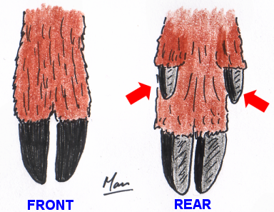  Simplified view of deer foot
Ruminant: An even-toed ungulate that chews the cud regurgitated from the rumen, the first of four parts of the ruminant’s stomach, to help obtain nutrients from its plant-based diet  Cud: Partially digested food that is returned from the first stomach, or rumen, to be chewed again in order to aid digestion through the remaining parts of the stomach | 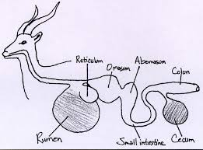  Ruminant digestive system
Dentine: A chalky material harder and denser than bone that makes up the bulk of a tooth and is the main component of ivory | 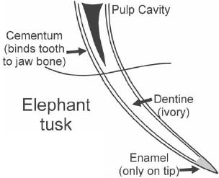  Dentine in elephant tusk

ANTLERS

Antlers occur -
- on cervids, or members of the deer family, of the even-toed, hoofed ruminants.
Cervids include white-tailed deer, elk, caribou and reindeer (basically domesticated caribou), and moose. Not all cervid species have antlers.
- Usually on males only. Exceptions are female caribou and reindeer.

Antlers -
- are bony extensions of the skull
- usually grow in symmetrical pairs and often have many branching points
- shed and regrow each year
- are covered with “velvet,” skin and soft hair with many blood vessels that nourish the growing bone, while the antlers are growing (see the actual elk and caribou antlers and the photo of the deer antlers in velvet below)

Antlers are used to -
- establish territory
- defend themselves
- attract and fight for mates
- reach vegetation below the snow (for caribou/reindeer)
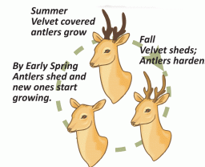
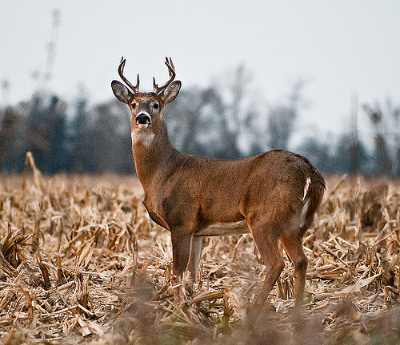  Younger deer’s antlers | 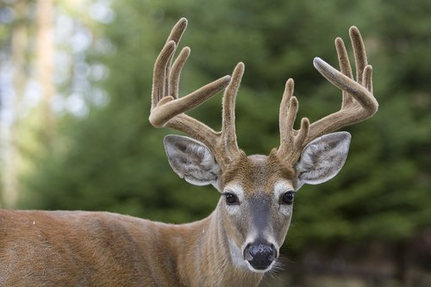  Older deer’s antlers in velvet | 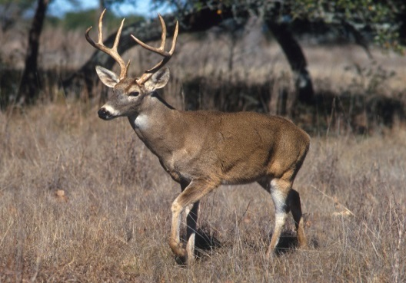  Older deer’s antlers  after losing velvet
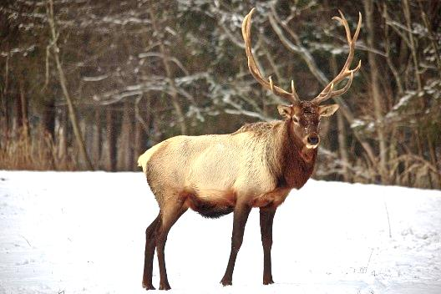  Elk antlers | 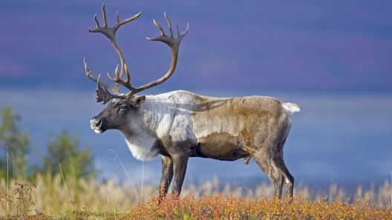  Caribou antlers | 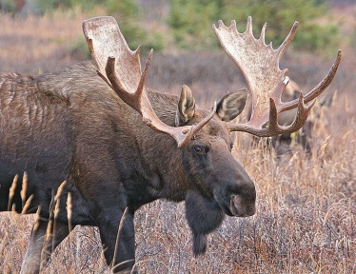  Moose antlers

HORNS (TRUE HORNS)

Horns occur -
- on bovids of the even-toed, hooved ruminants. Bovids include antelopes, gazelles, sheep, goats, cattle, musk oxen, bison, and buffalo
- on both sexes often

A horn –
- is a true horn, a hard projection on the head consisting of a live bony core with a sheath, or covering, made from keratin (Human hair and fingernails are also made from keratin.)
- is paired with another but each has only one point
- does not shed but is permanent
- continues to grow throughout the animal’s life
- if totally broken, will not grow back. If some horn remains, it will continue to grow but will never “catch up” to the other, unbroken horn.

Horns are used to -
- establish territory
- defend themselves
- attract and fight for mates
- root in the soil or strip bark from tree

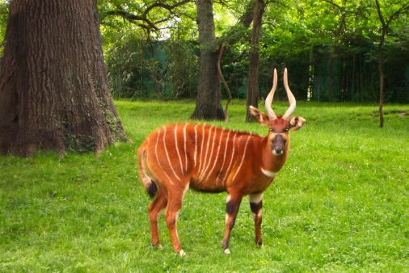  Bongo horns | 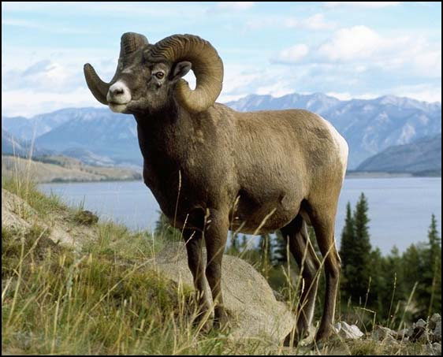  Male bighorn sheep horns
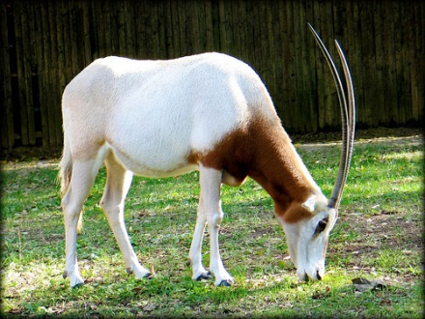  Scimitar-horned oryx horns | 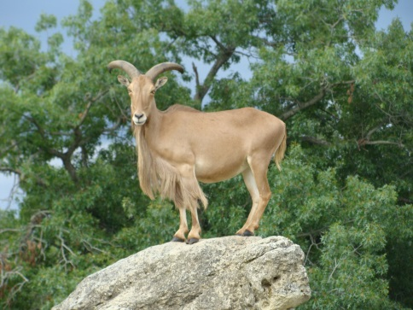  Aoudad horns

RHINOCEROS HORNS

Rhinoceros horns occur –  - in all species of rhinoceros: Two on white, black, and Sumatran rhinos, and only one on the greater-one horned (or Indian) and the Javan rhinos. Rhinos are odd-toed, hoofed animals.  - on both sexes  A rhinoceros horn –  - is not a true horn  - does not have a bony core  - is made of keratin (Human hair and fingernails are made of keratin.)  - continues to grow throughout the animal’s life  Rhinoceros horns are used for –  - defense of territory  - protection of calves  - maternal care  - foraging behavior  - sparring as part of the mating process | 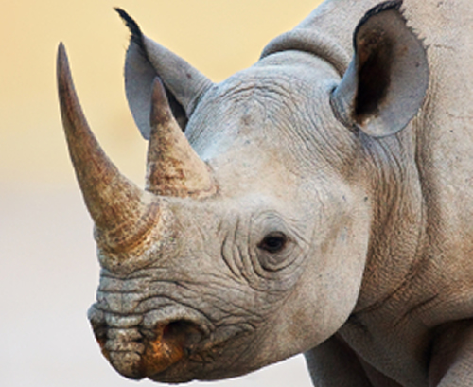  Black rhinoceros horns
SUMMARY OF ANTLERS, TRUE HORNS, & RHINOCEROS HORNS
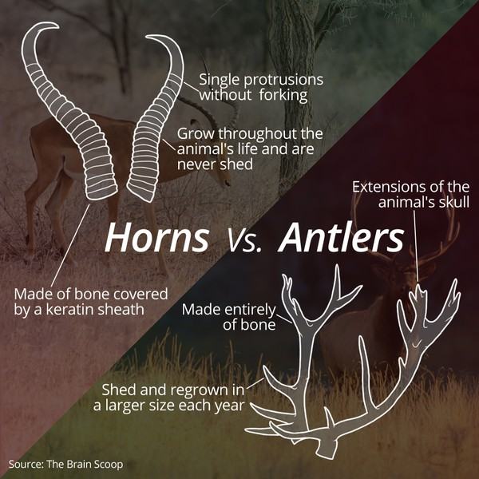  Summary of antlers vs. true horns | 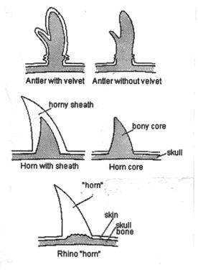  Comparison of structures of antlers, true horns,  & rhinoceros horns

TUSKS

Tusks -
- are elongated front teeth
- continuously grow
- are usually in pairs but not in all species (Male narwhals usually have one tusk.)
- stick out well beyond mouth
- are made of dentine with an outer layer of enamel. Dentine is the source of ivory.
- are usually canine teeth (as in walruses, pigs, and warthogs)
- are incisors in elephants
Walruses are carnivores. Their tusks are found on both sexes.  Walrus tusks are used to -  - forage for clams and shellfish from sandy ocean floor  - establish dominance  - defend against polar bears or killer whales  - break ice & help pull the walrus onto ice  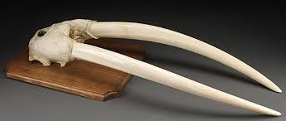  Walrus skull with tusks | 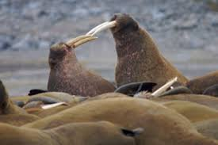  Two walruses fighting for dominance
Elephants are herbivores.  Both male and female African elephants have tusks. Some male Asian elephants have tusks.  Elephant tusks are used to –  - defend themselves  - attack  - dig  - lift objects  - gather food  - strip bark from trees | 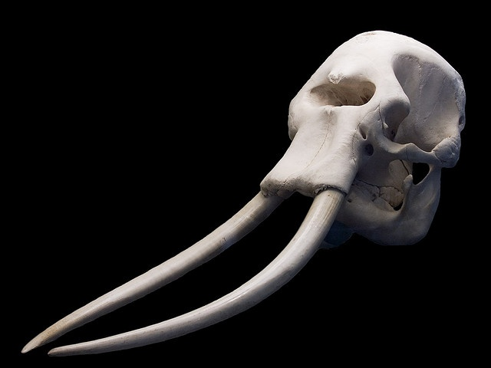  African elephant skull with tusks  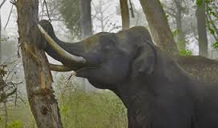  Asian elephant stripping bark from tree

©BIG Zoo Lesson, Potter Park Zoo, Lansing, Michigan
“Inspiring Conservation of Animals and the Natural World”

