Information for BZL Teacher-Led Lessons about Bird Skulls

OVERVIEW
- Focus on the beaks of the skulls and how they are adapted to the diet of that species.
Look at the size and shape of the beaks. Consider tools that do similar jobs as the beaks.
- Zoo staff will select -
  - About eight items from our bird skull collection, providing a wide variety of beaks
  - Photos like those presented below to illustrate points
- Note space provided by the open, airy eye sockets for well-developed eyes that see very well.
- Some of these skulls came from real birds and some are artificial. Both kinds are very fragile. Students should not touch. If you are a teacher with a class that will find it difficult to keep their hands off of them, you might want to present to the class rather than have the students observe the skulls on their tables.
- Anyone handling the skulls should wash their hands after the activity.
- Definitions for Teachers is background information for the lesson. Information follows on specific bird skulls in Potter Park Zoo’s Biofact Collection. Other resources include www.projectbeak.org Bird Education and Awareness for Kids and, for those with Project WILD’s Flying WILD materials, look for the Fill the Bill activity page.
DEFINITIONS FOR TEACHERS
Birds do not have teeth.  They do have beaks, or bills.  Beak (or bill): Horny projecting jaws of a bird.  - There is an upper and a lower jaw. The upper jaw grows out of the skull and cannot move independently of the skull.  - The lower jaw is hinged and can move independently of the skull.  - Beaks are covered with skin that produces keratin, the same material that makes up feathers, hair, and fingernails. This keratin makes the beak hard and strong. Keratin wears down but continuously grows to replace itself.  A beak serves as the bird’s mouth and hands.  Among its uses are to gather or capture food and handle it as needed to consume it, drink, feed young, preen, gather materials to make nests, defend itself, and (some grow special structures on the beak during breeding season) to attract a mate.  Generalist: A bird that eats a wide range of foods and is usually better able to adapt to changing environmental conditions.  A generalist type of beak:  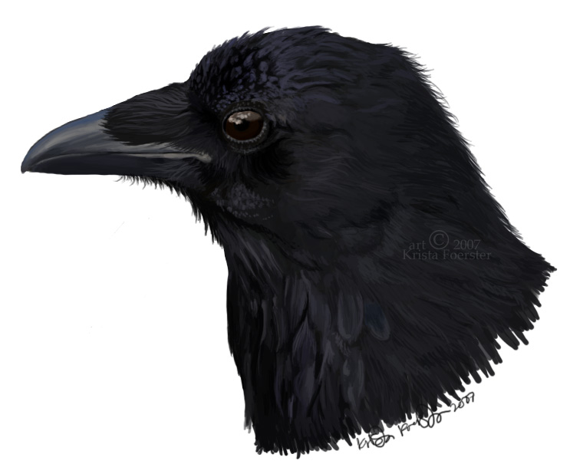 Multipurpose |  | Specialist: A bird that eats a narrow range of foods, such as only fish or only insects or only seeds. It is more likely to have special adaptations that allow it to capture/consume a special food, for example, particular size and shape of the beak.  Among the specialist types of beaks:  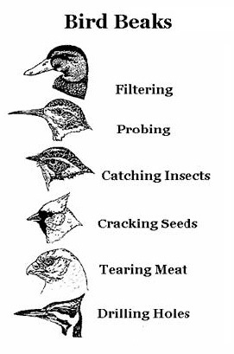  Adapted from University of Houston graphic
GENERALIST BIRD SKULLS
In the Potter Park Biofact Collection
American Crow  - Omnivore  - Eats a wide variety of things, including worms, birds, frogs, nuts, fruits, seeds, and garbage  - Multipurpose beak  - Related PPZ exhibit: Raven  - Tool: Swiss army knife, not because it looks like it but because it functions for eating many different food items  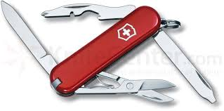 |  | 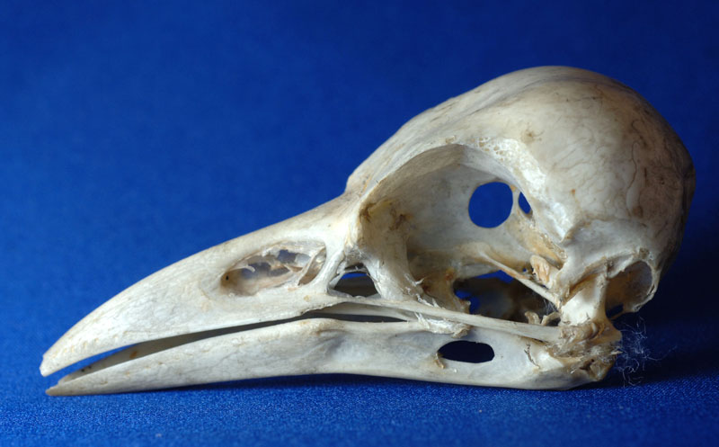
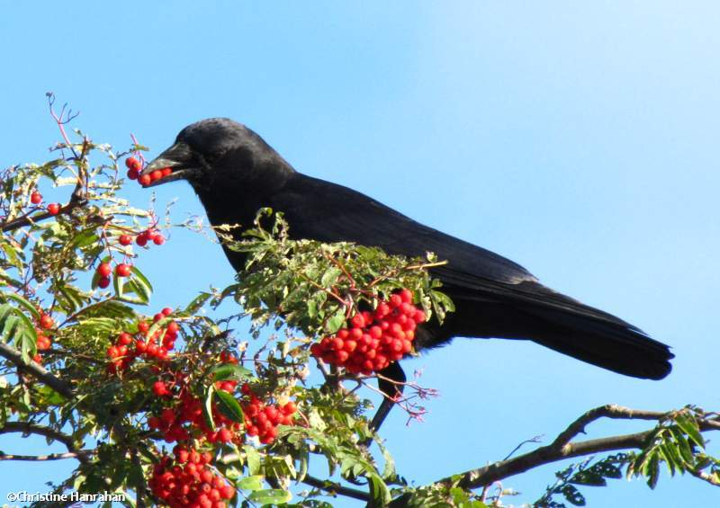  Eating berries | 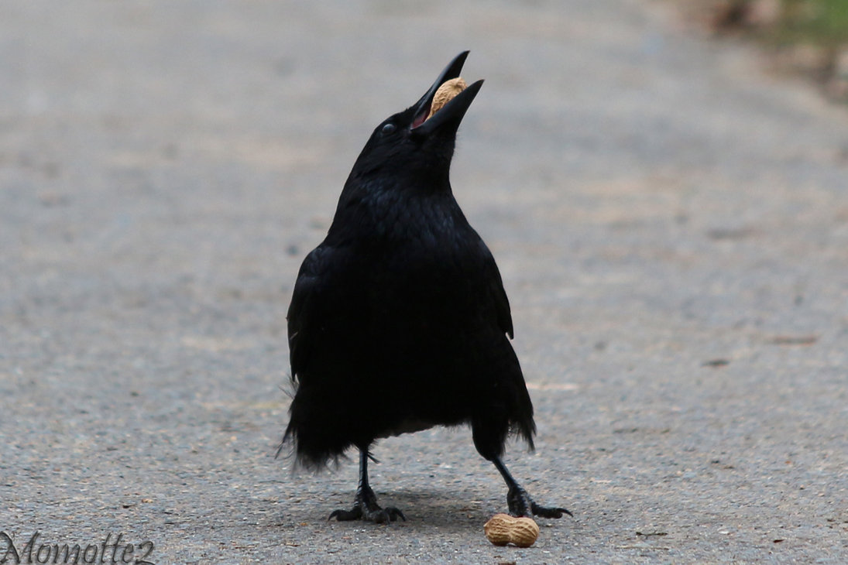  Cracking peanuts |  | 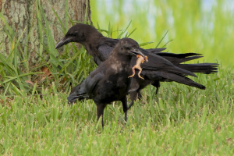  Carrying frog
SPECIALISTS BIRD SKULLS
In the Potter Park Zoo Biofact Collection
Primarily Fish Eaters
Great Blue Heron  - Carnivore  - Primarily eats fish, also other small animals  - Long, pointed beak  - Striking beak  - Related experience: Great blue heron on river  - Tool: Spear | 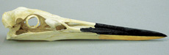 |  |  | 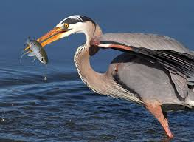  Catching fish with beak

Bald Eagle  - Carnivore  - Primarily eats fish  - Grabs fish with talons, tears meat from prey with sharp-hooked beak  - Tearing beak  - Related PPZ exhibit: Bald eagle  - Tool: Meat hook  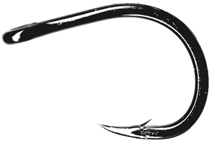 |  | 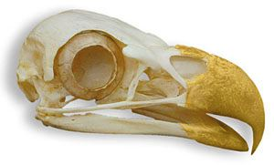
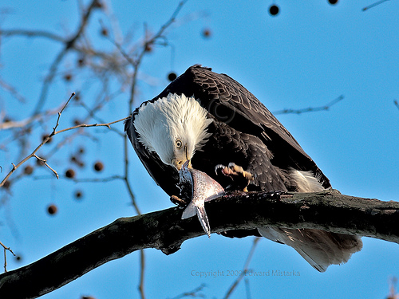  Tearing fish | 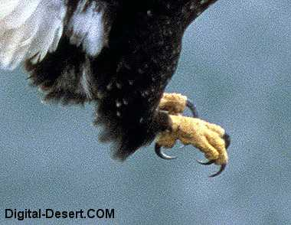  Talons |  | Catching fish with talons
Magellan Penguin  - Carnivore  - Eats fish, squid, & krill  - Long, tapered, beak with small hook for grabbing prey  - Grabbing beak  - Related PPZ exhibit: Magellan penguin  - Tool: Salad tongs  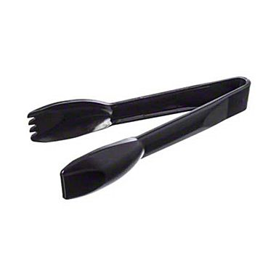 |  | 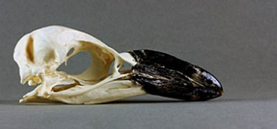
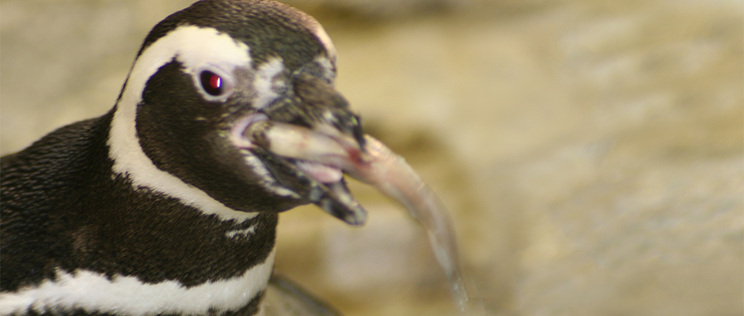  Eating fish |  | 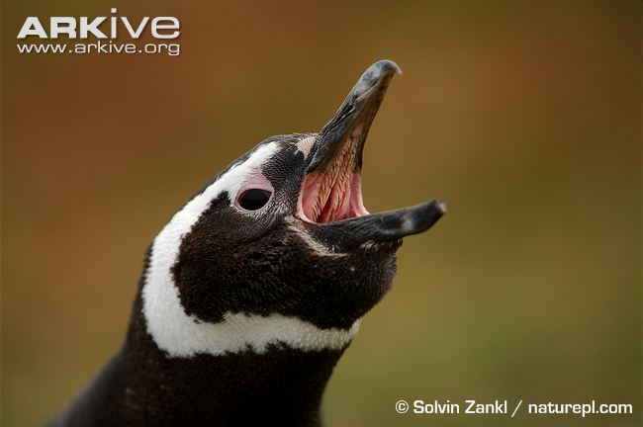  Spiny features in mouth & on tongue

White Pelican  - Carnivore  - Opportunistic feeder, eating small fish, also salamanders, tadpoles, & crayfish  - Bird floats on the surface and scoops fish into pouch as they swim by, pouch contracts, water drains out, & bird swallows fish whole  - Sometimes groups work together to herd fish for easy feeding  - Large beak pouch from lower jaw  - Scooping beak |  | - Tool: Scoop  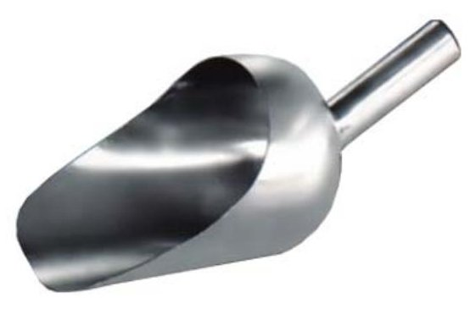  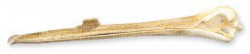  Beak with breeding-season bump, minus pouch
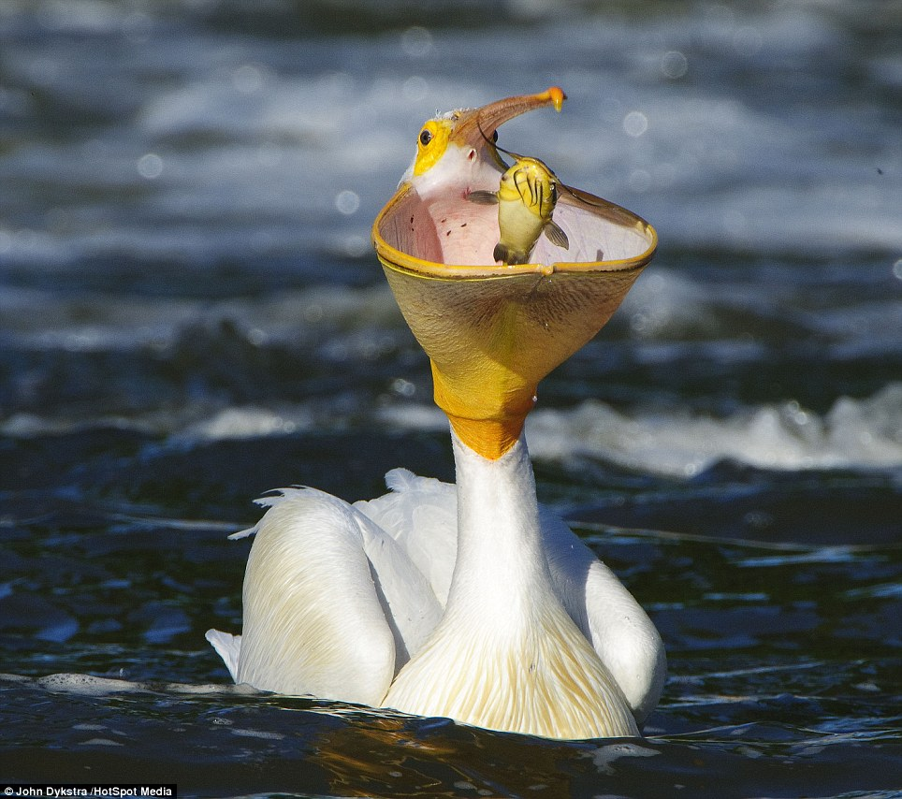  Catching fish in throat pouch |  | 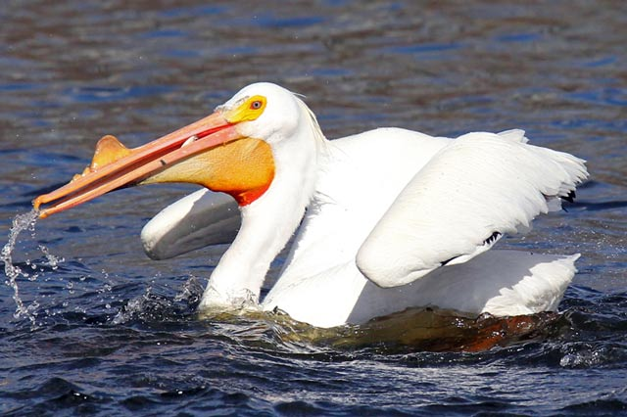  Scooping fish into throat pouch
Fruit & Seed Eaters

Cardinal  - Omnivore  - Eats seeds, grains, fruits, & insects  - Short, stout, cone-shaped beak  - Cracking beak  - Related experience: Cardinal as a backyard bird  - Tool: Nutcracker or pliers | 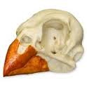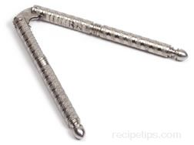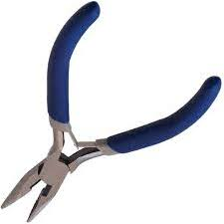 |  | 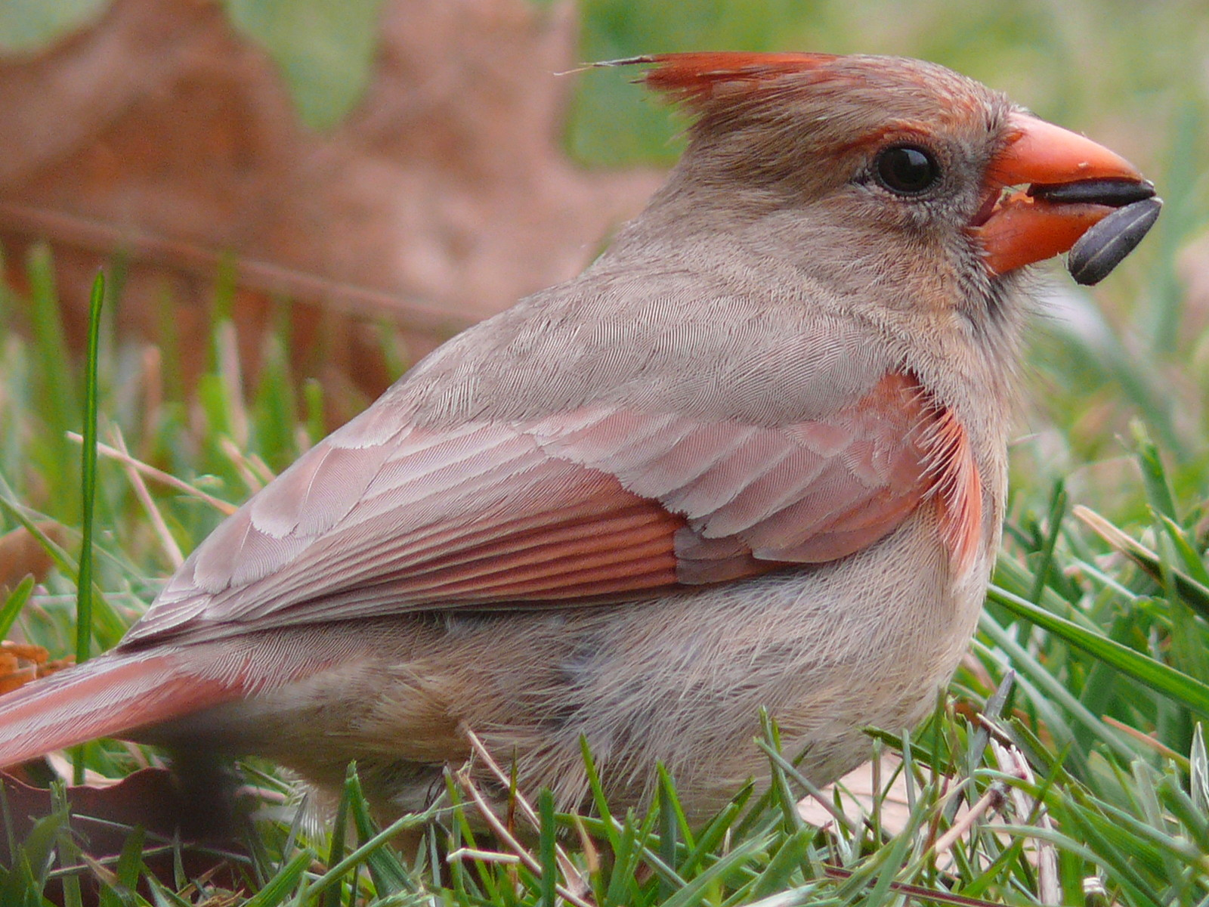  Cracking seeds

Macaw  - Primarily herbivore  - Eats seeds, nuts, flowers, fruits, leaves, stems  - Crushing beak  - Also used for climbing  - Tool: Nutcracker | 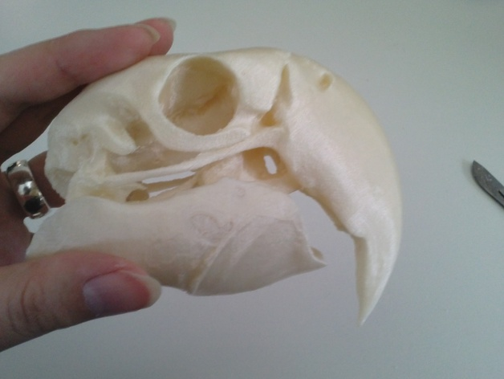  _________________________  Parrot: A bird from the large group of psittaciformes. It is often brightly colored, with a short down-curved hooked bill, grasping feet, and a loud voice. It is found especially in the tropics and feeds on fruits and seeds. Many are popular as pets, and some are able to mimic the human voice. | 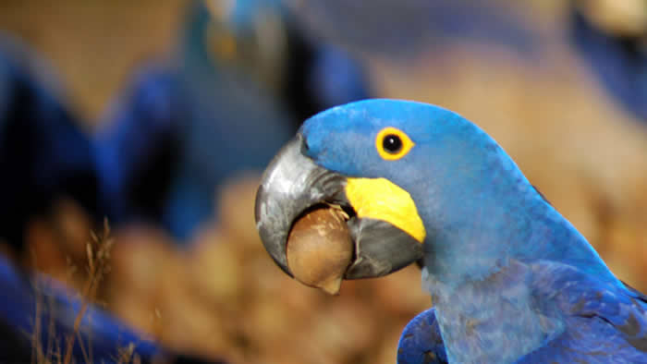  Macaw crushing nut  _________________________  Macaw: Types of parrots characterized by long-tails and brightly colored feathers, native to Central and South America.

Green Aracari  - Omnivore  - Primarily eats fruit, occasionally insects  - Reaching & plucking beak  - Serrated edge (like a steak knife) helps to grip fruit & slice through the skins of fruits. (They use their long tongue to roll the fruit back and forth over the rough edge until the skin breaks.) They swallow the fruit whole.  - Related PPZ exhibit: Green aracari  - Tool: Tongs & steak knife | 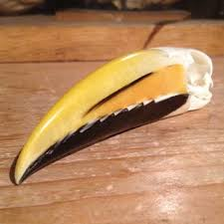  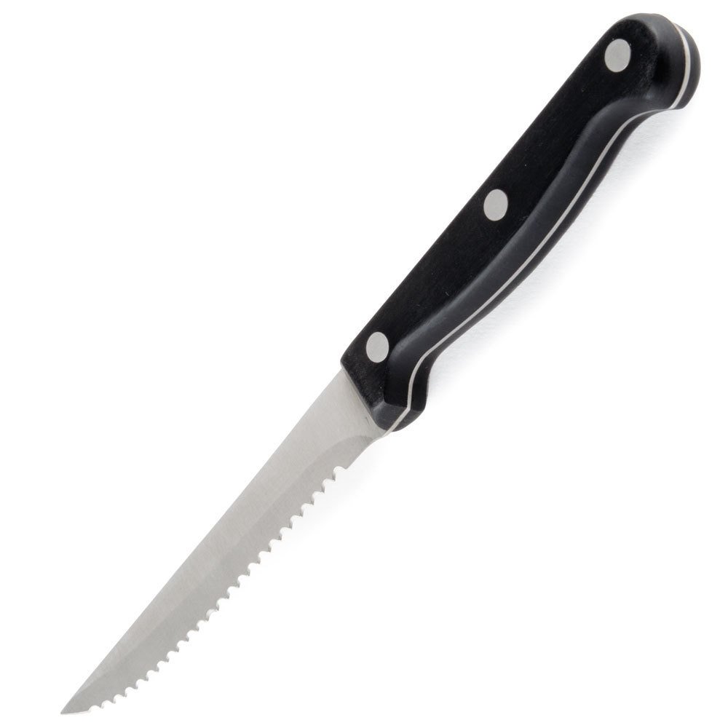 | 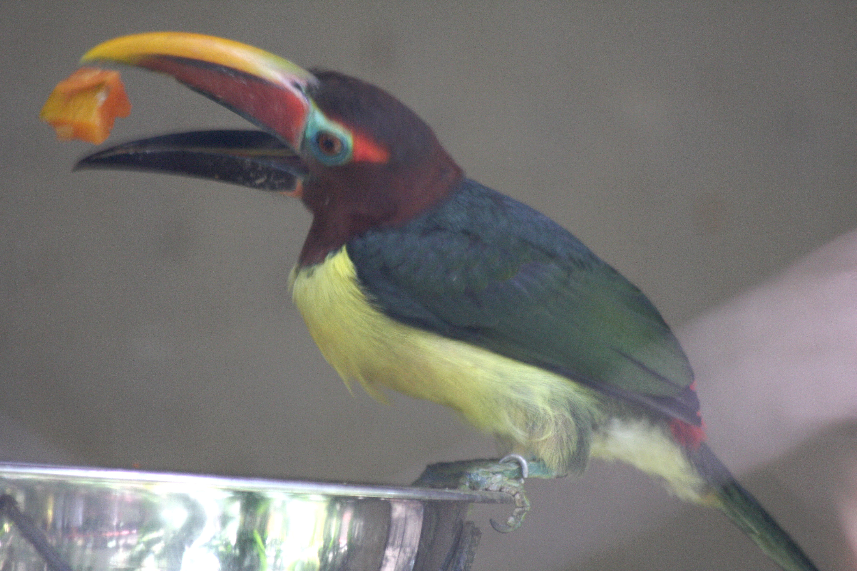  Eating fruit  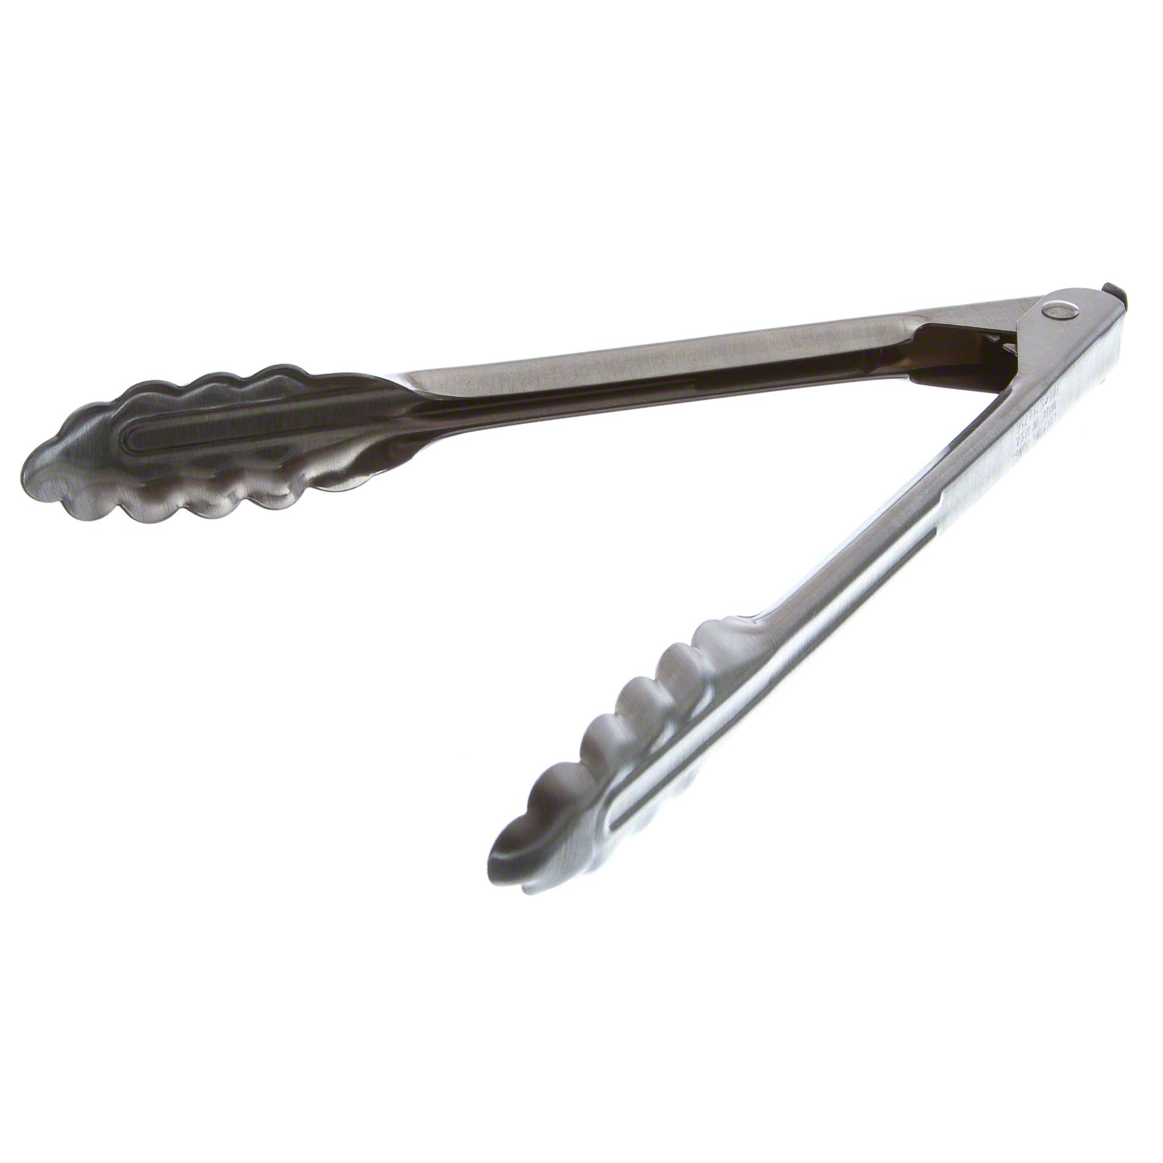
Other Omnivores

Duck  - Omnivore  - Eats small aquatic plants and animals  - Skims the surface of the water to strain food from muddy, shallow water with tiny comb-like structures around the edge of its wide, flattened beak  - Filtering beak  - Related experience: Ducks in river  - Tool: Strainer | 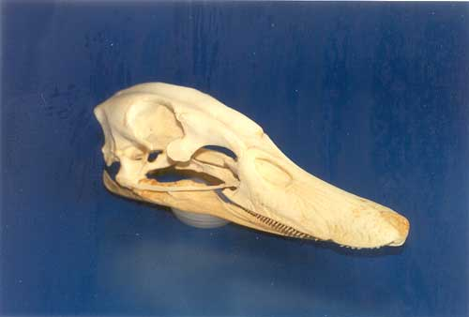  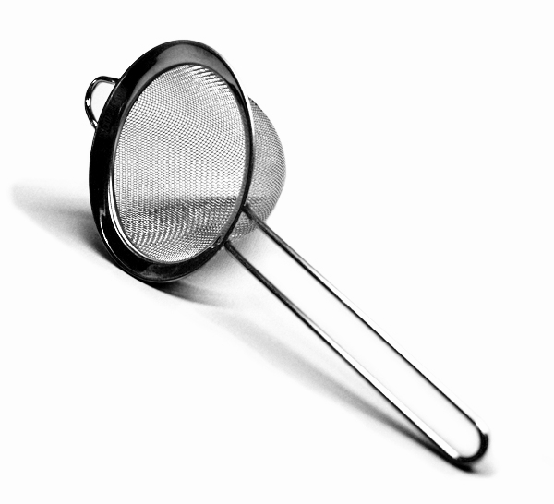 | 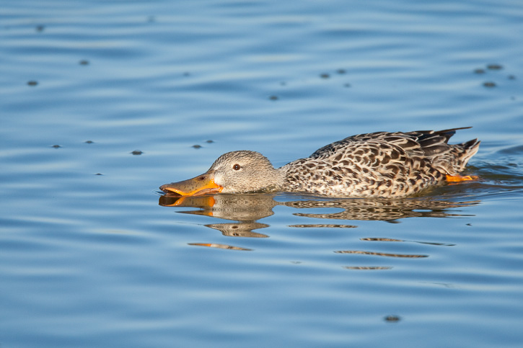
Pheasant  - Omnivore  - Eats seeds, grasses, roots, leaves, insects, snails, & earthworms, typically off the ground  - Scratches with feet and digs with beak to find food  - Short, pointed beak to pick seeds off the ground  - Picking beak  - Related PPZ exhibit: Peafowl, chicken  - Tool: Tweezers | 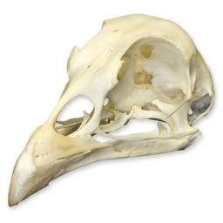 | 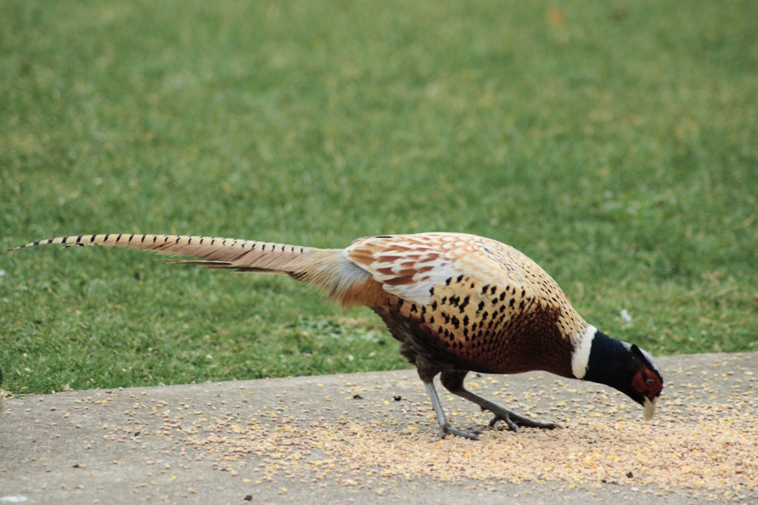  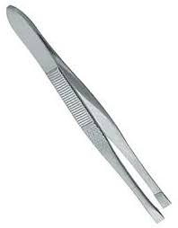

©BIG Zoo Lesson, Potter Park Zoo, Lansing, Michigan
“Inspiring Conservation of Animals and the Natural World”

