Information for BZL Teacher-Led Lessons about Mammal Skulls
Carnivores, Herbivores, and Omnivores
Overview
- Focus on predator/prey, examining differences in teeth, eye size and placement, and size of nasal passage.
- Teacher Resources: University of Arizona’s Wildlife Skull Activities and the notes below on Potter Park Zoo mammal skulls
- Zoo staff will select at least two each of the carnivores, herbivores, and omnivores listed below for classes to use in a lesson. Large groups may have more. (If you prefer a different set up, please let zoo staff know in advance.)
- Students should not touch skulls. Some are real, and some are artificial. All are fragile. Please respect the materials. Anyone handling the skulls should wash their hands after the activity.
- The sources of our real skulls are animals that die. We do not kill the animals for the skulls, as students sometimes think.
Carnivores
Siberian wolf (gray wolf, coyote, and fox skulls are similar but smaller)  Note the large canines for piercing and holding prey, and sharp molars that overlap each other with a scissor-like motion for cutting and tearing flesh. Eyes are oriented to the front to produce binocular vision, allowing better depth perception for judging distance from prey. Large nasal passage indicates strong sense of smell. | 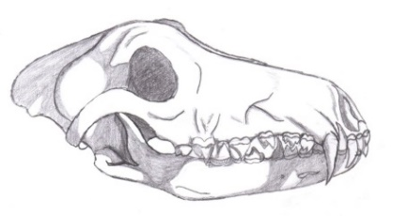  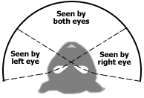
Amur tiger (lion is similar; cougar and bobcat skulls are similar but smaller)  Similar to the above. The cat nasal passage, however, is shorter than the dog’s, indicating that while the sense of smell is very good, there is less of a reliance on the sense of smell and more on the other senses. | 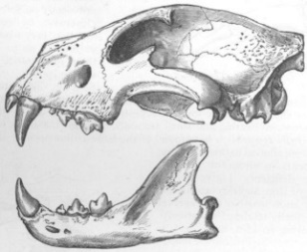
River otter  Similar to the above. Note that the head is flatter with the eyes oriented to the front and positioned towards the top of the skull. The eyes, ears, and nostrils are above water when the otter swims at the water’s surface. | 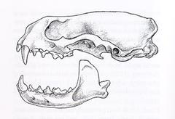
Giant anteater  This insectivore has no teeth but has a tongue that darts into insect mounds, up to 150 times per minute, and its sticky saliva and barbs pick up termites and ants. They have a very good sense of smell and not-so-good senses of sight and hearing. | 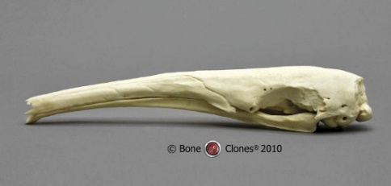

Herbivores
Pony  Ponies have chewing molars. The incisors are used for tearing plants. The zoo’s skull has canine teeth, indicating that it is a male. (These teeth are probably a throw back from the tusks that their ancestors used to have, perhaps used for fighting for females.) Their eyes are high and off to the side. They have a very good sense of smell, reflected in the large size of the nose. | 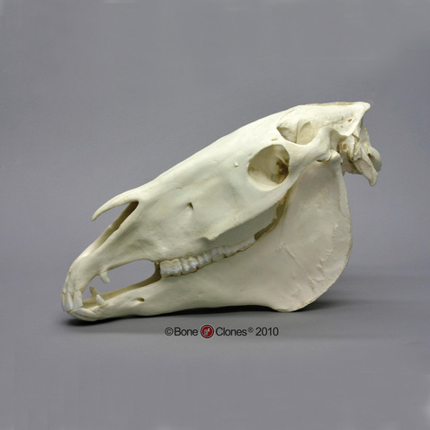  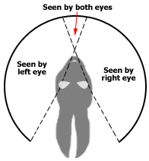
White-tailed deer (moose skull is similar but much larger)  Note the flat molars that grind plant material. Instead of upper incisors there is a hard, rough palate that is used much like teeth. Also, the eyes are oriented to the sides, better to detect predators while eating. Good sense of smell reflected in size of nasal cavity. | 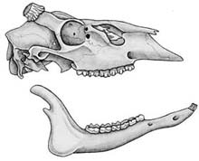
Rabbit  Rabbit molars are flat for grinding plant material. The incisors are used for tearing plants. Their eyes are high and oriented to the side. | 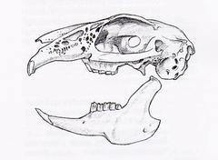
Porcupine/Beaver  Note the four large front teeth (incisors) that grow continually. The orange enamel on the outside surface is harder than the inner surface. With use, the softer inner surface wears down and the harder outside surface produces sharp edges that are very effective for gnawing tree bark and woody material. Molars are flat for grinding plant material.  Beaver is similar but larger. Eyes, ears, and nostrils are high on the skull for swimming on the water’s surface. | 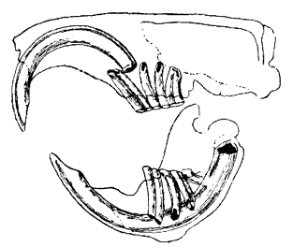  Porcupine skull  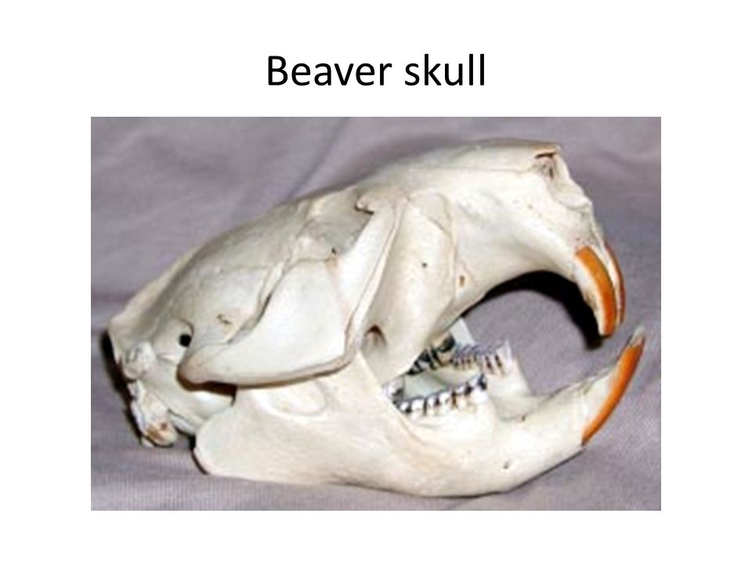

Omnivores
Black bear  Bears have a mixture of carnivore and herbivore characteristics. Canine teeth are used for capturing and killing other animals, and incisors are relatively large for cutting plant materials. Molars are a combination of sharp, scissor-like teeth to shear meat and teeth with more rounded cusps for grinding and crushing plant material. Eyes oriented to front, good sized snout. | 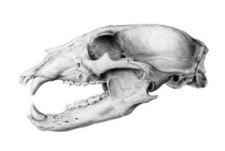
Spider monkey (crab-eating monkey is similar but the canine teeth are more developed)  These teeth are similar to human teeth, but the canine teeth are more developed. Brain case large, eye sockets large, and flattened nose - emphasizing vision and ability to learn over sense of smell. Flatter molars than carnivores and herbivores, but incisors are a little better developed than carnivores and herbivores. Eyes oriented front for binocular vision for arboreal movement as well as seeking prey. | 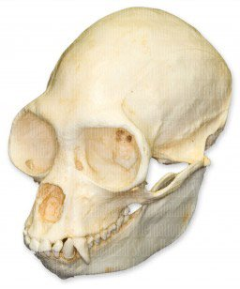
Mandrill  Mandrills eat plants, insects, and small animals. While males can use their large canine teeth to hunt prey such as small antelopes, exposing those canines are important for dominating others in the group. Females are much smaller with much smaller canines.  Note the incisors in the front for biting off plant material and the flat molars for grinding plant material. Consider similarity to human teeth. Eyes are oriented forward.  Notice the underlying bony structures of the blue snout. | 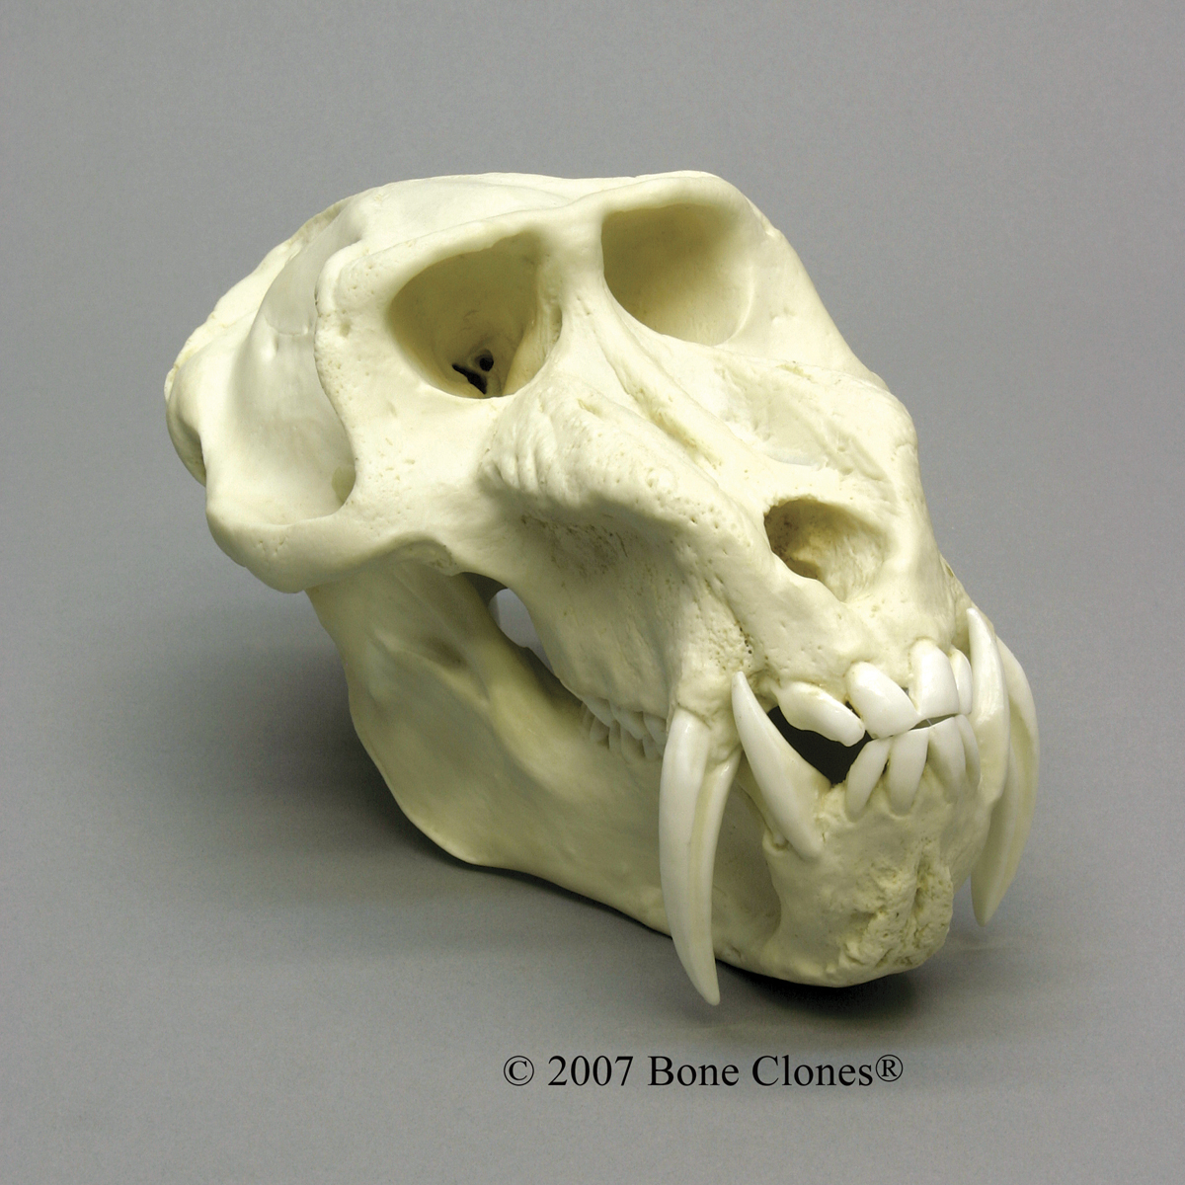
Opossum  An opossum has long, sharp canine teeth, so it does catch and kill food. It also has grinding molars to eat plants. The eyes are situated more toward the front, right over the nose. A long nasal cavity indicates a good sense of smell. | 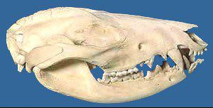
Red panda/Raccoon  Red pandas are classified as carnivores but primarily eat bamboo. They have carnivore-like incisors and canines but molars like those of herbivores. Their eyes are oriented forward.  A raccoon skull looks similar but the predominance of plants and animals in its omnivorous diet varies by its habitat. Its molars are more pointed than the red panda’s bamboo-grinding molars. | 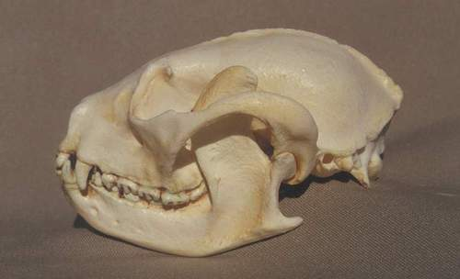  Red panda  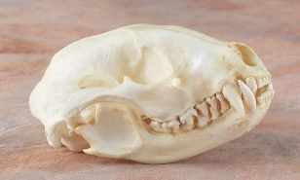  Raccoon
©BIG Zoo Lesson, Potter Park Zoo, Lansing, Michigan
“Inspiring Conservation of Animals and the Natural World”

