Information for BZL Teacher-Led Lessons about Bird Feet
Overview
- Studying a bird’s skull and especially its beak provides valuable information about a bird’s diet. Including its feet can add to knowledge of its habitat and behavior.
- Zoo staff will select –
- About eight different photos of bird feet, providing a wide variety of foot types. They will match to whichever bird skulls are being used from the Zoo’s skull collection. The photos will be enlarged versions of those presented below.
- The chart below is a summary of the more common bird foot types with illustrations and connections to their adaptations. Not all of the feet on the chart match to skulls in the Zoo’s collection.
- 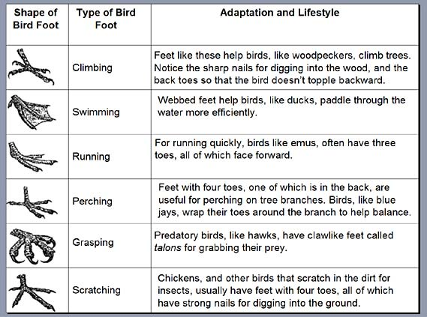Other resources include www.projectbeak.org Bird Education and Awareness for Kids at https://www.biologycorner.com/2016/07/12/bird-beaks-and-feet/
 | Wading | Birds like herons and cranes have long, thin legs that help it walk through shallow water to find aquatic insects, amphibians, and fish. Their long toes, with three pointing forward and one pointing back, help them balance through mud.
Chart adapted from the Norman Bird Sanctuary, 2004

Bird Feet Photos that Match to Bird Skulls
in the Potter Park Zoo Collection
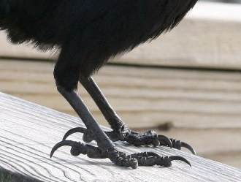  Crow – Perching feet | 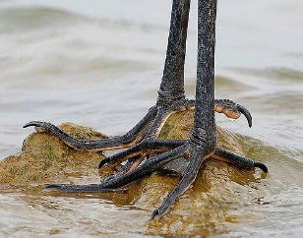  Great Blue Heron – Wading feet
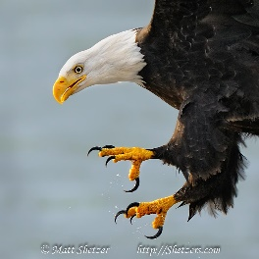  Bald Eagle – Grasping prey feet | 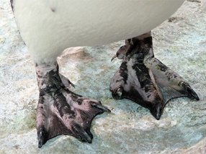  Magellan Penguin – Swimming feet that also function as snowshoes on snow and ice
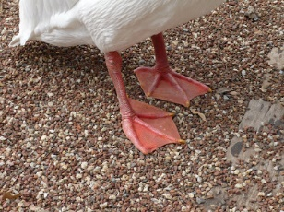  White Pelican – Swimming feet | 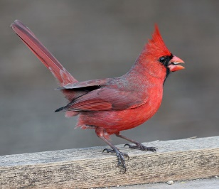  Cardinal – Perching feet
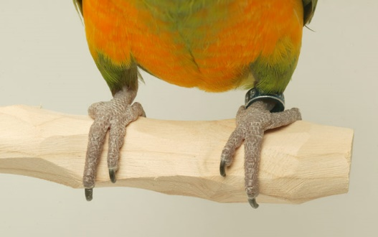  Macaw – Climbing feet | 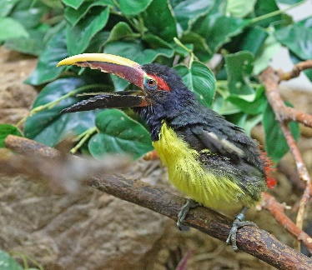  Green Aracari – Climbing feet
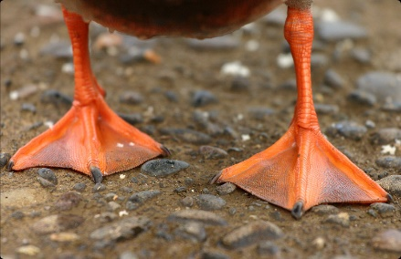  Duck – Swimming feet | 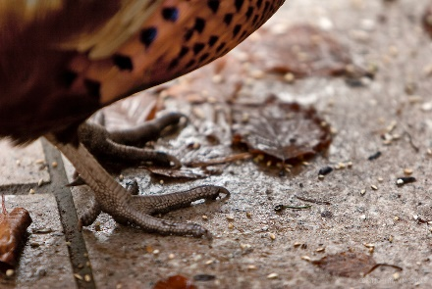  Pheasant – Scratching feet
©BIG Zoo Lesson, Potter Park Zoo, Lansing, Michigan
“Inspiring Conservation of Animals and the Natural World”

