MYSTERY BAGS ABNL
STEP ONE:  Give each child a grocery bag. Each bag contains one artifact.  (Nature artifacts can be: branch of pine tree, pine cone, shell, bone, skull, feather, etc).  Make sure the kids don’t look into the bag—this is a mystery!  Place the bag on its side, student’s journal is next to the bag.  Carefully reach into the bag and FEEL your artifact.  Don’t tell what you might think it is.  In your journal, write words that describe your artifact.  Next, draw the shape of the artifact. | 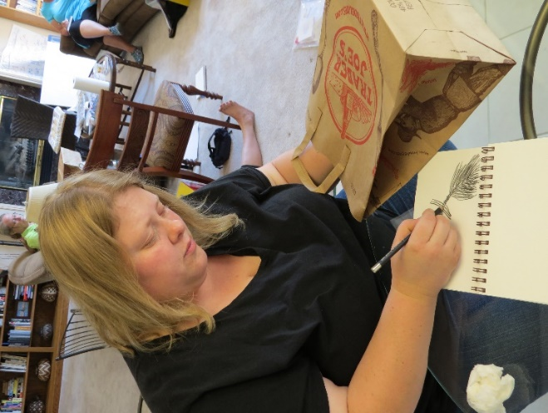
STEP TWO:

Take the artifact out of the bag. Does it look the way you thought it would look?

Next, put your journal into the bag. Place the object next to the bag.

Without looking into your bag, place your pencil on the page and the pencil stays on the page without lifting it up. Look at the object only, keep your pencil down without lifting it up, and draw the outer edges and lines of your object.

This is a BLIND CONTOUR DRAWING

Pay attention to lines and outer edges of what you’re drawing.

STEP THREE:  Take your journal out of the bag and then draw the object, again, this time looking at your object and your paper.  This is a CONTINUOUS CONTOUR DRAWING.  Contour drawings train your hand to draw exactly what you see. Draw the outline of your object and then add details to your drawing. | 