Information for BZL Teacher-Led Lessons about Penguins
Artifacts and Photographs

BODY STRUCTURE
Skull (This is very delicate and should not be touched by students and only by the teacher if requested for use inside the building.) - Note that this skull does not have the external beak on it. The beak is made for catching fish and other sea life.
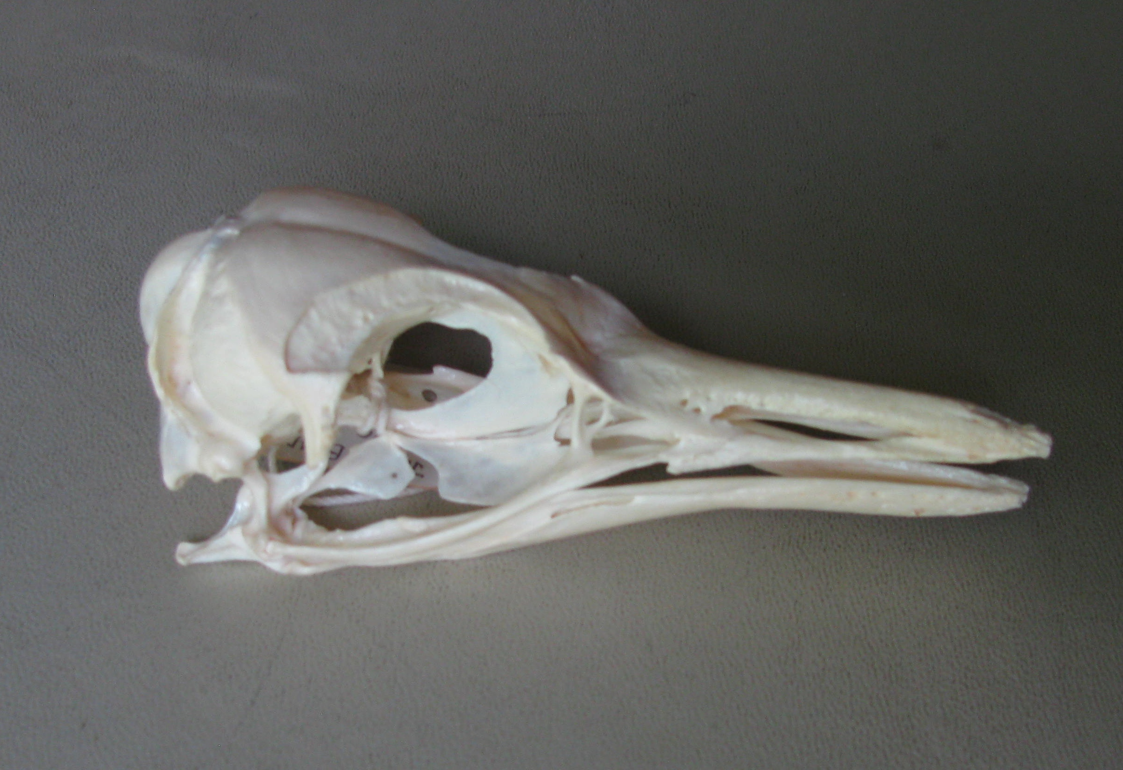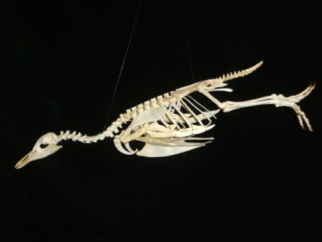
Skull without beak* Skeleton
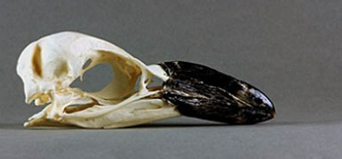
Skull with beak
Mammal bone vs. bird bone (Hold the mammal bone in one hand and the bird bone in the other to feel the difference in weight; look closely at the ends of the bird bone and you may be able to see some of the honeycomb inside.) - Mammal bones are solid. It is important that they be strong to support the animal. Most bird bones, that is, those that fly, however, are hollow (or honeycomb shaped inside). These lighter bones help birds get into the air as they fly. Birds that do not fly, such as penguins and emus, have solid bones like mammals.
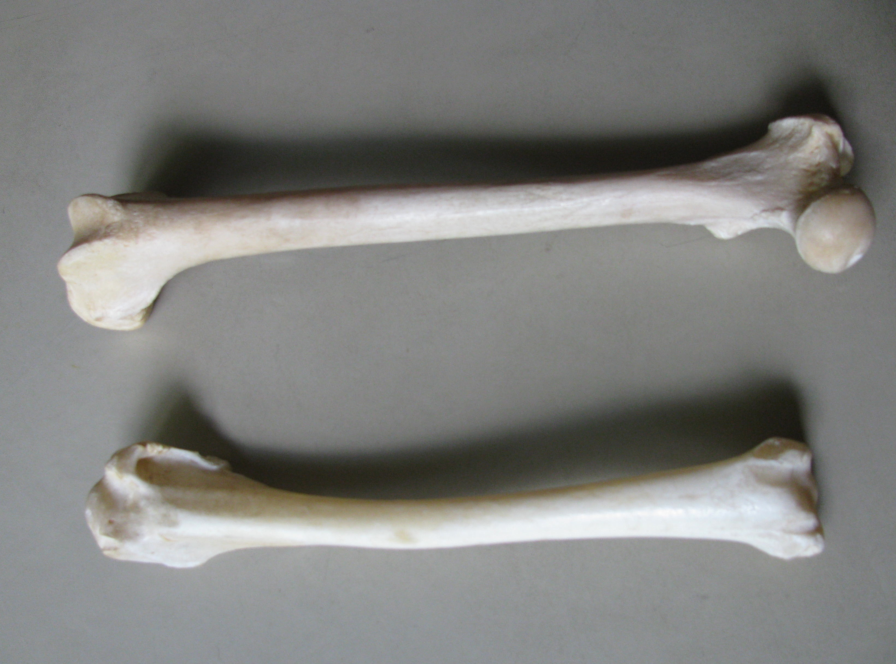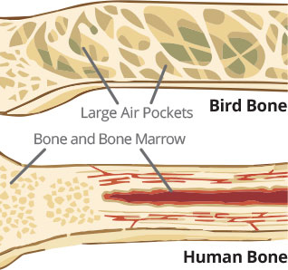
Mammal & bird bones* Solid mammal bone & hollow bird bone
* Indicates an object that we have that can be shared with the teachers.
Other photographs can be made available to teachers as well.

Flippers (Show flipper) - The flipper is a modified bird wing. Their flipper bones are not quite like a flying bird’s wing. They are flatter and broader. They do not have visible “elbows.” They can only move their flipper at their shoulder. Solid bones help make them stronger and less buoyant in the water. They can swim 13-15 mph. They have a bird’s “flying” motion underwater, “porpoising” about six feet out of the water at about nine mph.

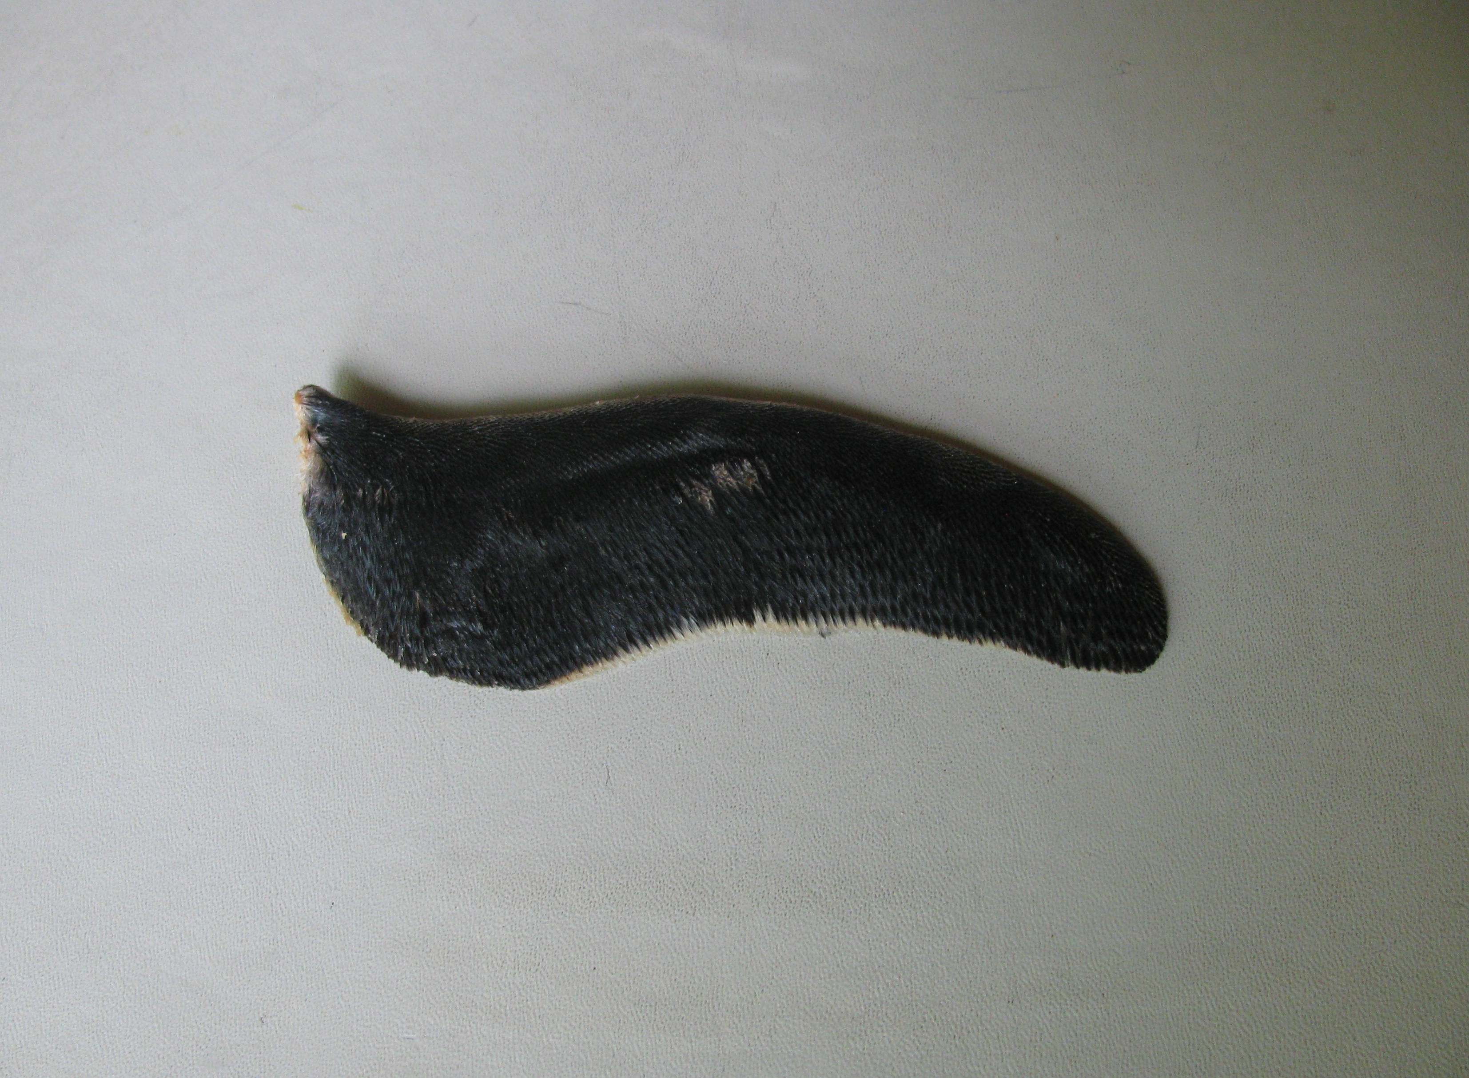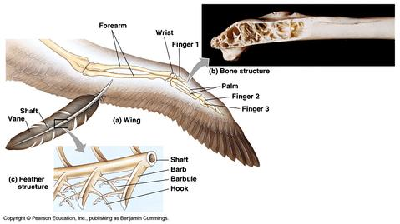
Flipper*

Down feathers (Show bag of down feathers. Please do not open the bag as the feathers will be all over.) - Down feathers are the small hair-like feathers that trap warm air close to the penguin’s body.

Molting - Penguins molt once a year. New feathers push out old feathers, usually in August or September at the zoo. They might look like “an exploding pillow.” Before, they gain a lot of weight, eating double or triple the daily feed. Then they start losing feathers. They are not waterproof while molting. They stay on land, do not eat, and live off their fat. Molting takes three-to-four weeks. By September or October at the zoo, they have their new feathers. As juveniles molt and grow new feathers, they look more and more like an adult.

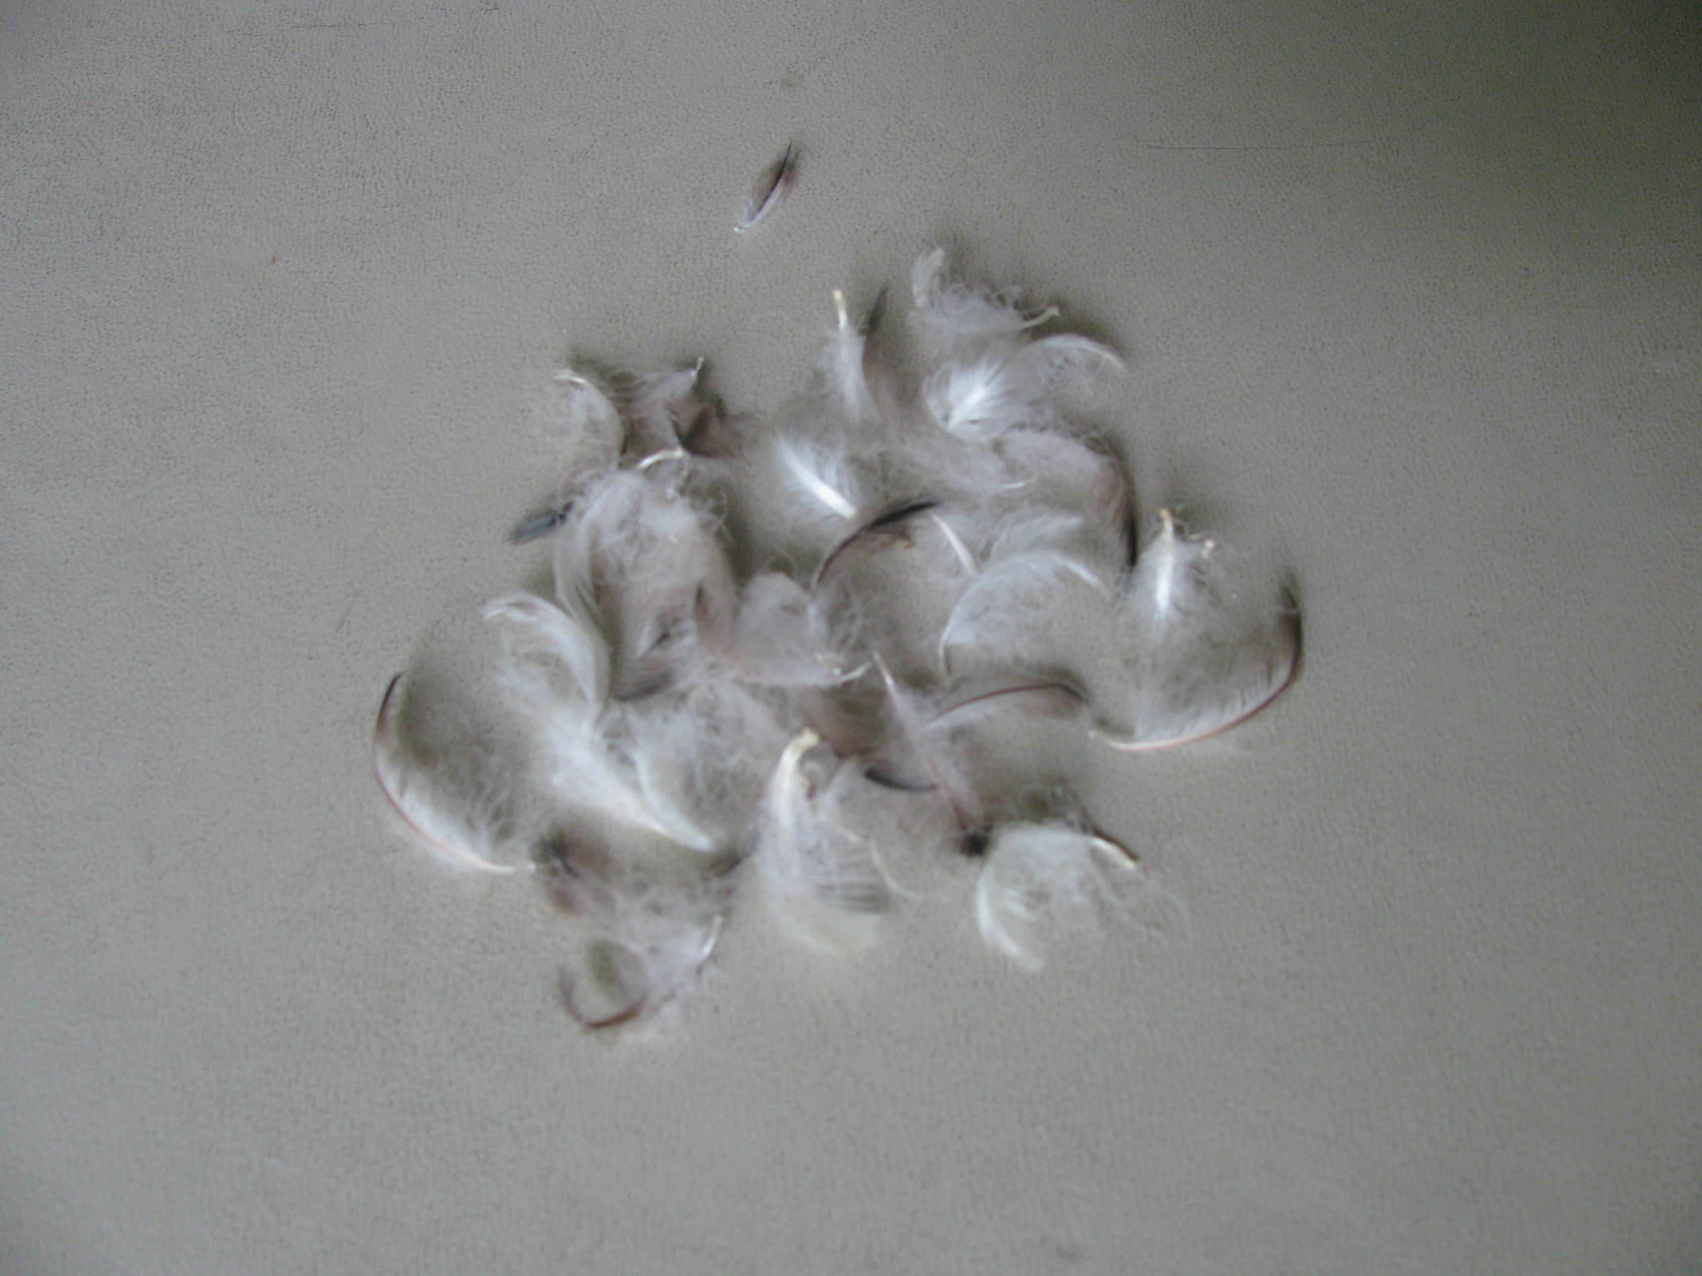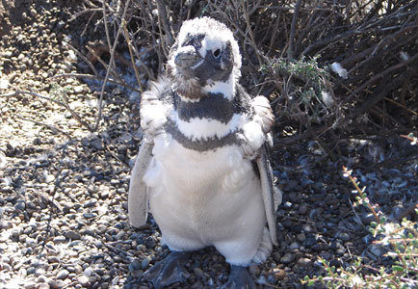
Down feathers* Molting penguin

PREDATOR-PREY
Penguins have no teeth. They swallow prey whole and have small, spiny features inside the mouth and on the tongue to help the food down their throats.
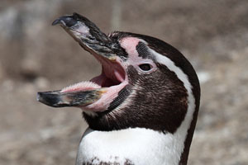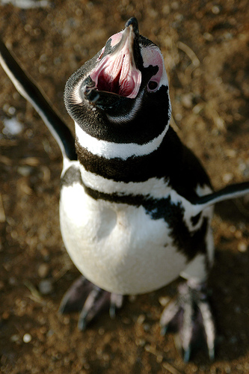
Spiny features on tongue Spiny features on roof of mouth

Some of the penguin’s prey in the wild
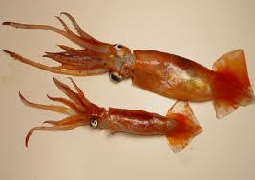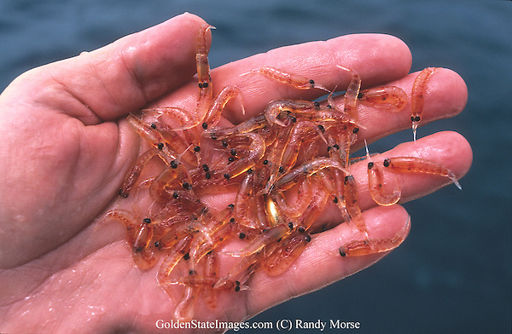
Squid Krill

Some of the penguin’s predators in the wild
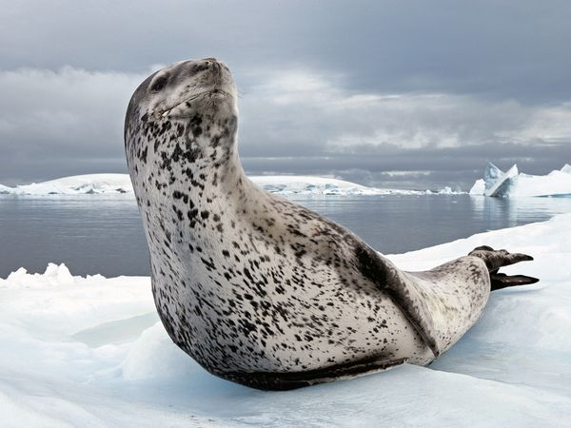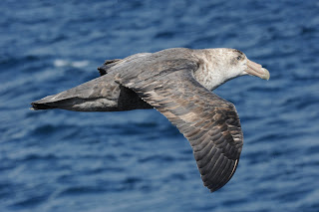
Leopard seal Petrel

Countershading - Dark back blends in with the water when viewed from above, while white front blends in with sky when viewed from below.
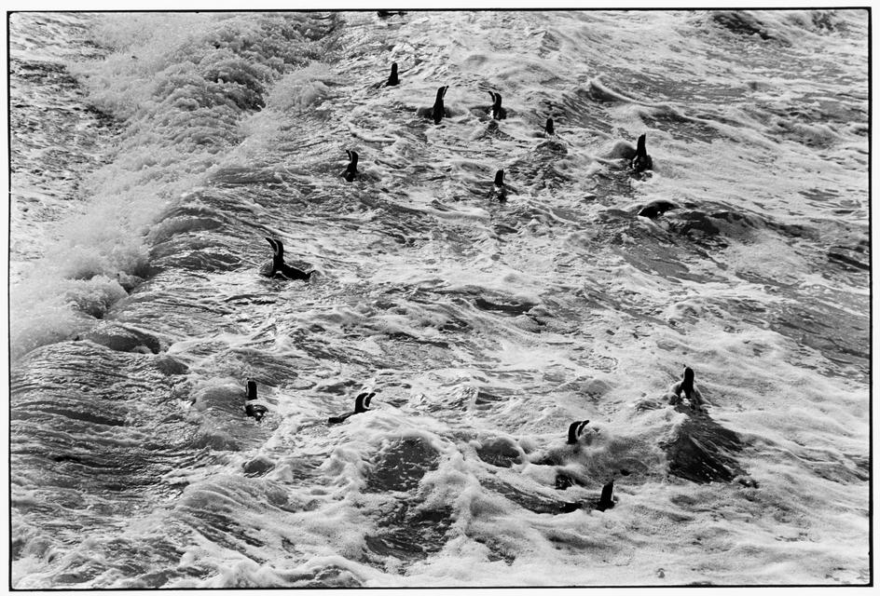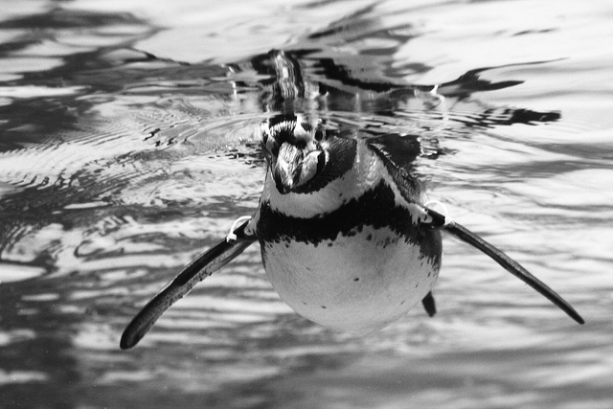
View from above, blends with water View from below, blends with sky
AT THE ZOO
Penguin feeding sheet - While feeding the penguins, the zookeeper records how many fish – and what kind – that each penguin eats. It is important that each penguin gets their pill fish, the first fish of the day, which contains vitamins and medicine they need. Then they can eat as much as they want. Keepers keep track of how much they eat, because not eating for a few days could be a sign of illness.

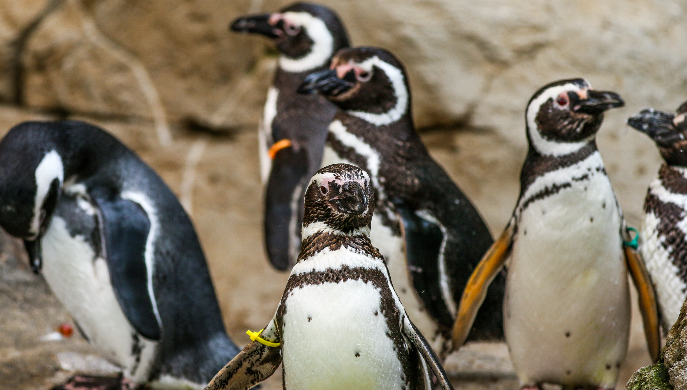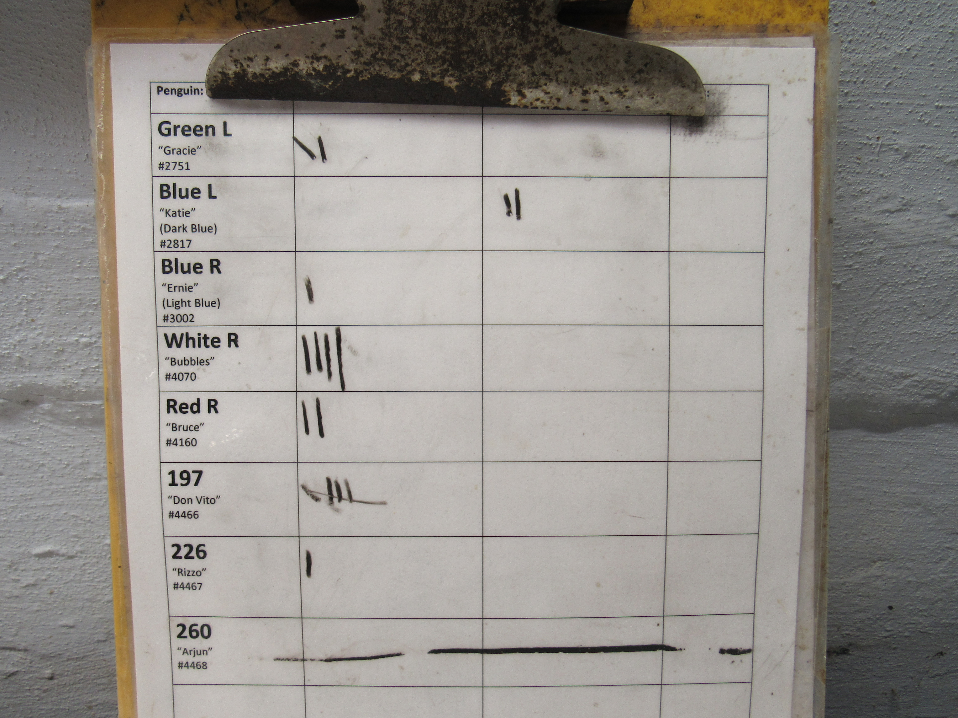
Penguins with colored ID tags Feeding sheet

Each penguin is identified in the left-hand column. There is a color and initials “L” or “R,” representing the left or right flipper that the band is on. Penguins with bands on the left flipper are females; those on the right are males. Each has a different color.
In the middle columns there are initials that stand for the food that they eat. “C” stands for the number of capelin fish each eats, and “H” stands for the number of herring fish each eats.

Nest boxes - Protected areas where two animals pair up, lay eggs, incubate, and take care of newly hatched chicks.

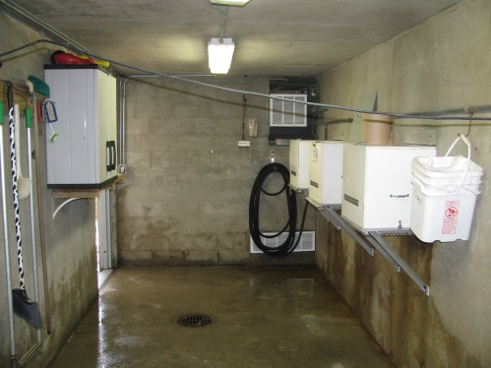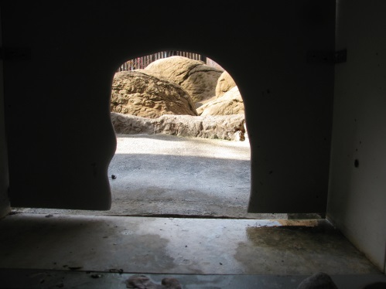
Nest boxes from inside work area View to the outside from nestbox

IN THE WILD & GROWING UP
Nests in the wild - Nests are built in burrows or under bushes in the wild, and not as near to the water as here at the zoo.

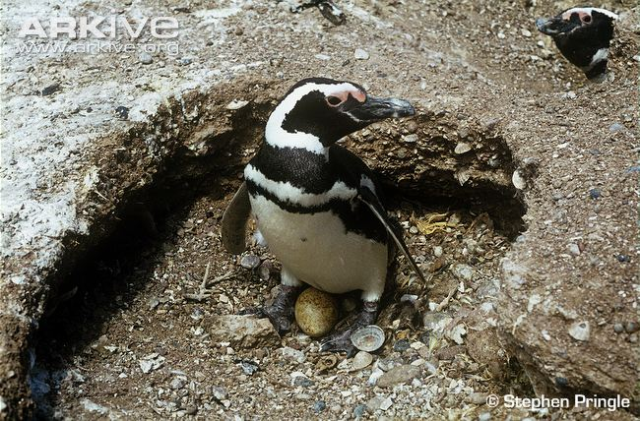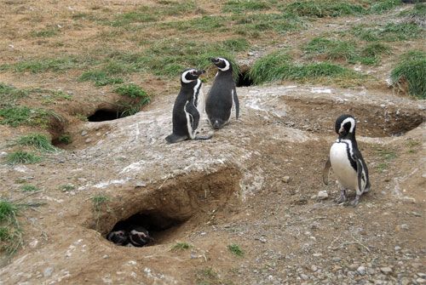
Parent with egg View of nests in wild

Young growing up

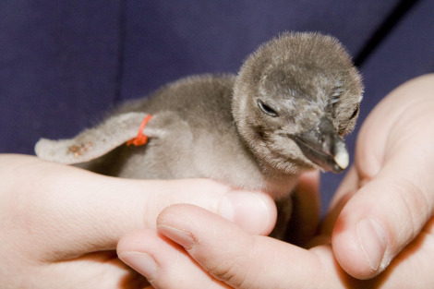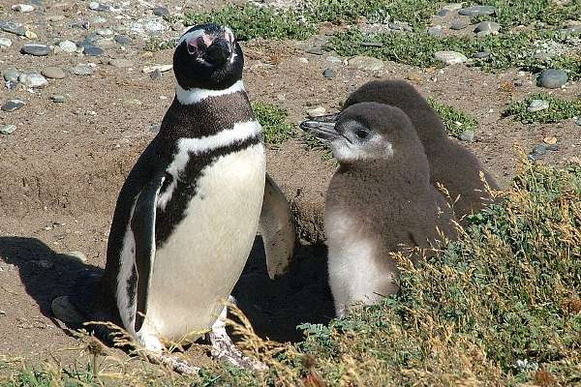
New chick (15-24 days) Young getting older

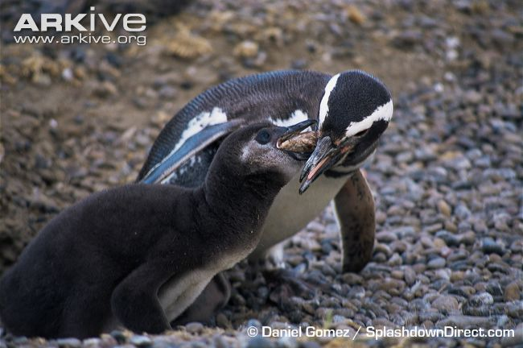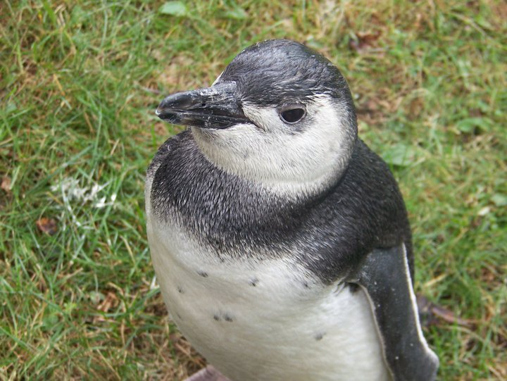
Parent feeding young About 2 months old, soon
ready for the water, will look like this
until it molts at about 2 years

ZOO STORIES
Photo of coin with hole - This penny was thrown into the exhibit and swallowed by a penguin. The holes illustrate the danger that coins pose to the penguins. The penguin’s digestive juices are so strong that they eat through the coin. The metals then enter the penguin’s blood system and can make the penguin very sick or even kill the penguin. This coin was regurgitated by a sick penguin. In the past, we had penguins get sick and one died from this. NOTHING SHOULD BE THROWN INTO AN EXHIBIT BY VISITORS.
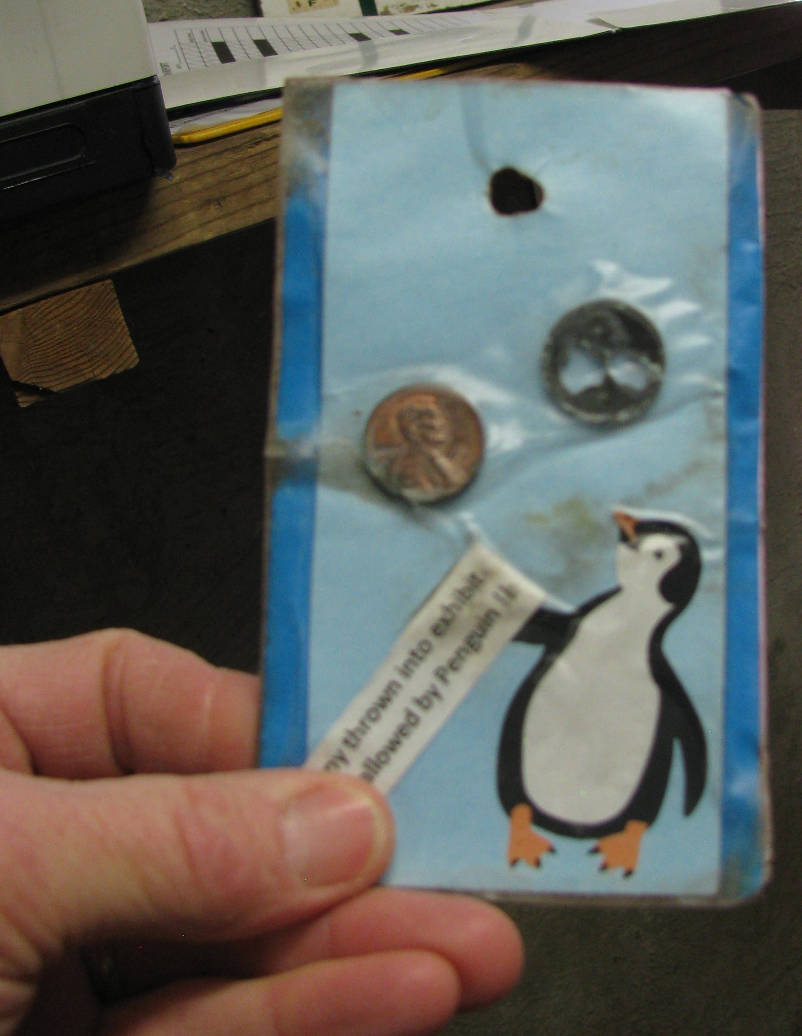Comparing a regular penny with one that had been in a penguin’s stomach

Rock egg - Years ago we had one female and nine males. The males without mates were very restless and aggressive during nesting season. We put rocks about the size of penguin eggs into their nest boxes. They sat on them as if they were eggs. It kept those males busy and less aggressive, and gave them practice for when they become dads. Parenting is a skill that can take practice, and sometimes the parents break the eggs they are incubating.

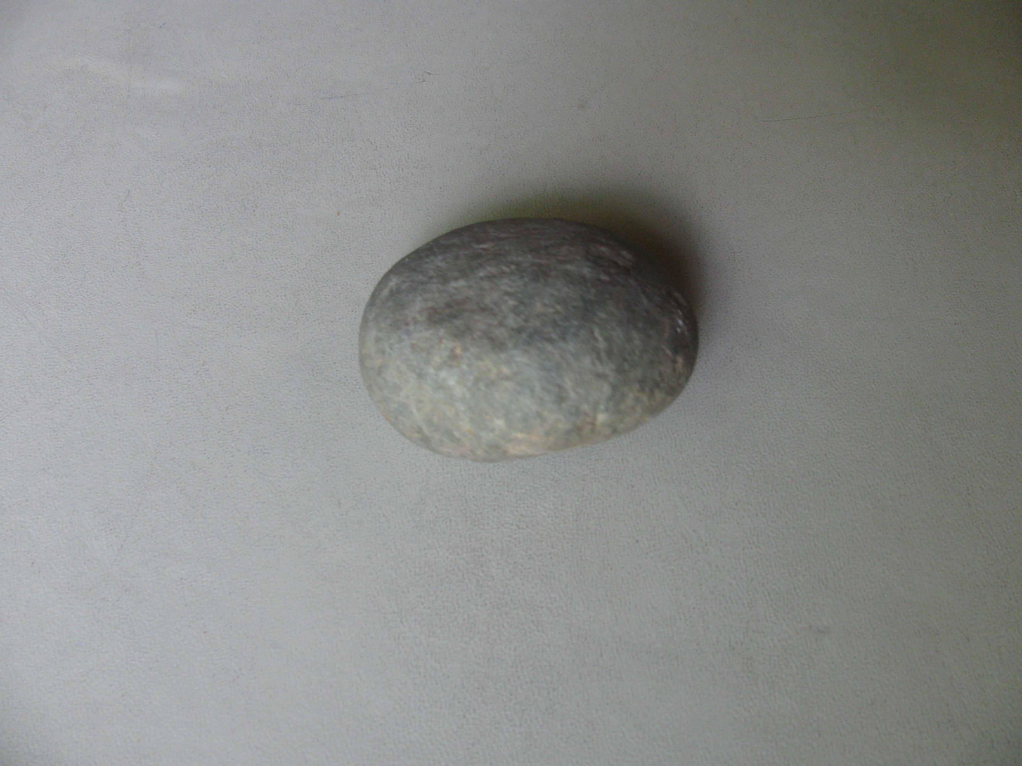
Rock egg

©BIG Zoo Lesson, Potter Park Zoo, Lansing, Michigan
“Inspiring Conservation of Animals and the Natural World”

